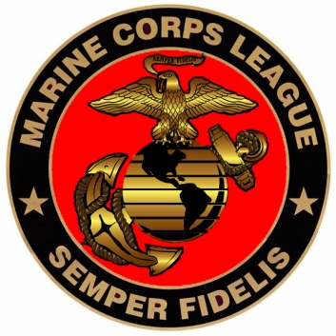
Tarheel Detachment #733 1775
Marine Corps League
18, May, 2015
Cary, NC Date:

Pay To The Order Of: BRIAN D. ALSTON $
1,000.00

One Thousand and 0 / 100 Dollars

Memo: Young Marine Scholarship Award
Commandant

